How to Schedule an Appointment with Your Advisor
When making an appointment, phone, zoom, and in-person appointments are offered on a regular basis. However, with DePaul practicing social distancing to prevent the spread of COVID-19, advisors are working from home and requesting that students schedule phone and zoom appointments. If you are requesting a phone appointment, please provide your phone number in the appointment description (step 9 discusses adding in comments, that would be where you add in your phone number). If you are requesting a zoom appointment, please specify in the appointment description, and the advisor will email you a link for the meeting. If in-person, please await confirmation from the advisor about whether this can be accommodated. For phone and zoom appointments, when it is time for your scheduled appointment, you should have your DPR open to facilitate discussion with your advisor.
There are steps below on how to schedule an appointment with your advisor online. You may also visit youtube.com/watch?v=x3z9NM-rDFU for a very helpful, step by step video tutorial on scheduling an appointment with your advisor online through BlueStar.
- Log on to your Campus Connect
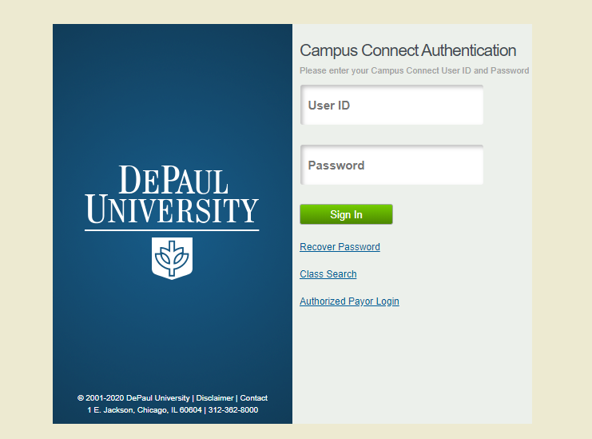

- Click on the “Student Resources” box
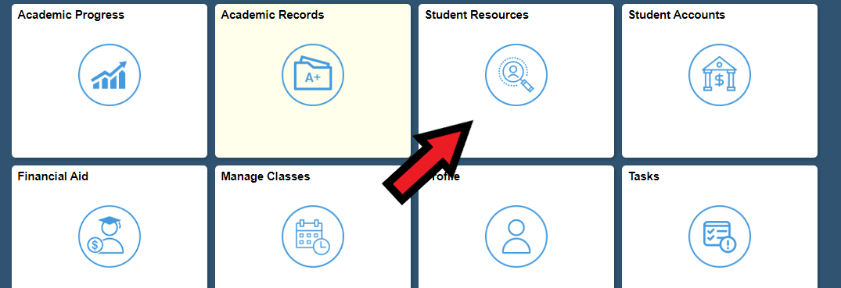
- Click on “BlueStar Student Support” in the left hand menu. This will take you to your “My Success Network”.
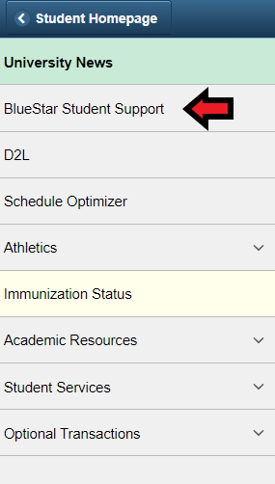
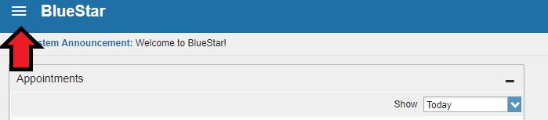
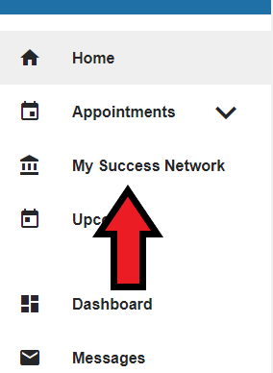
- In the list of your connections, click on the name listed as your assigned advisor. For BIO/NEU students (that are not Pathways Honors students), Jaimie Engle should show as your assigned advisor. Since advising assignments are not updated automatically when students change program plans, if you do not see Jaimie as your assigned advisor, please email jengle@depaul.edu so that Jaimie can update your advising assignment. If you’re a Pathways Honors student, you will continue working with your Pathways advisor who you will see instead of Jaimie in your “My Success Network.”
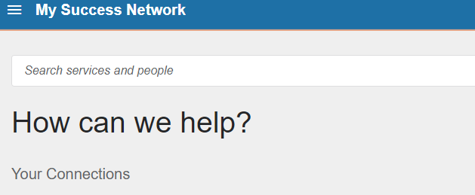
- Click the blue “schedule appointment” box on the left hand side
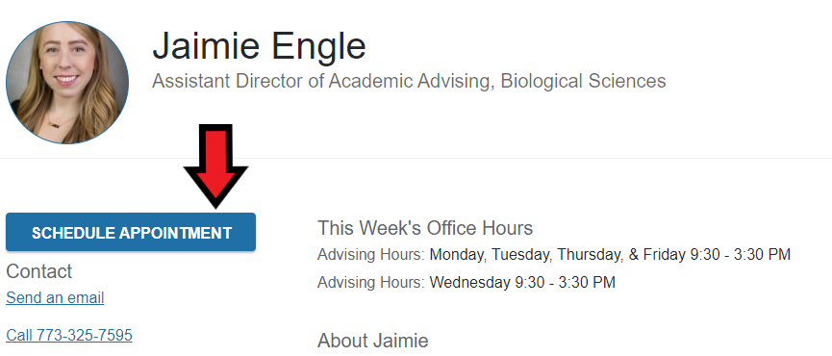
- Use the drop box to select what your appointment is for
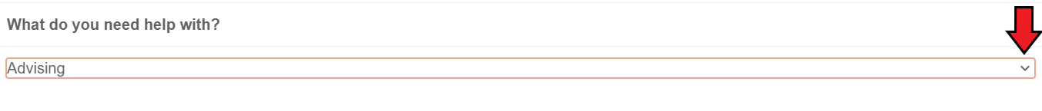
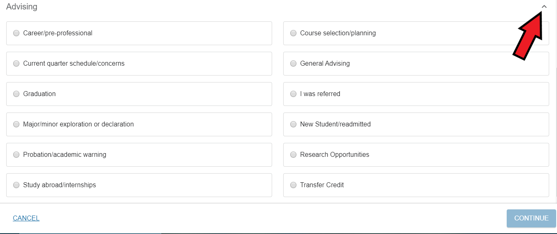
- Use the calendar on the left hand side to select the date(s) for which you are available
- Select your appointment time slot on the right hand side and then press the blue ‘continue’ button all the way on the bottom right hand side
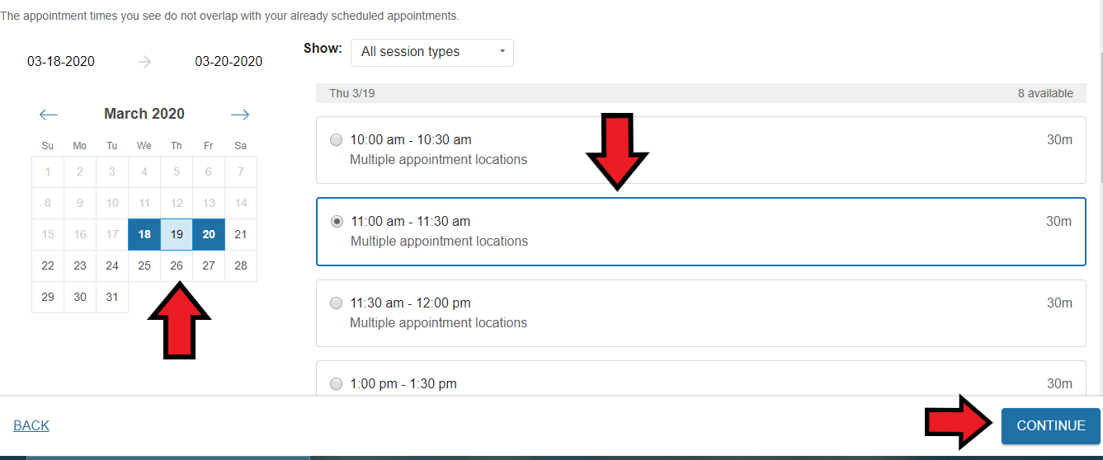
- Check to make sure the duration of the appointment, location of the appointment, and reason for visit are correct. If not, you can change them at this time. You may also add a comment about why you are making an appointment to provide a bit more information for the advisor, although it is not necessary.
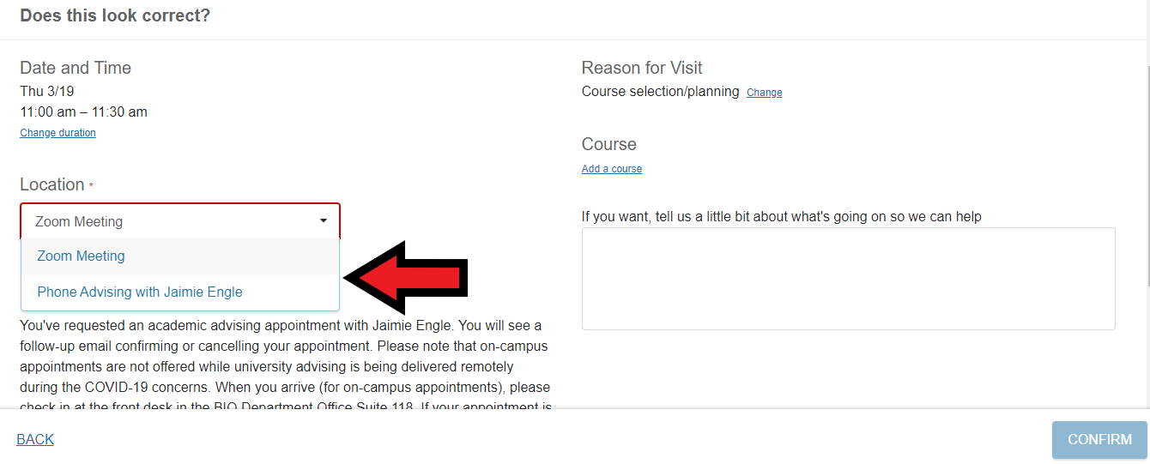
- If everything looks correct, scroll down to the bottom and press the blue ‘continue’ button on the right hand side.
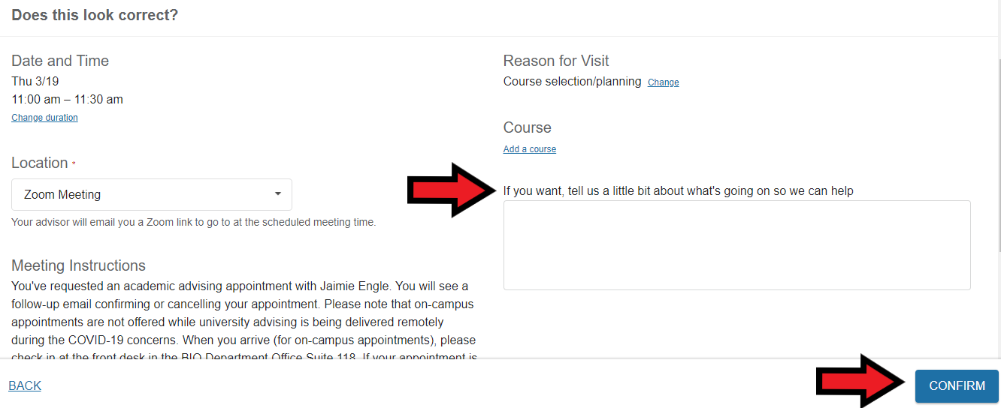
- You have now scheduled your appointment.
- If you would like, you can confirm that your appointment has been scheduled. To do so, return to the main services page from the beginning (this is the page where you selected your advisor’s name before you began to schedule an appointment). Once you are there, click the drop box at the very top left hand corner and click on the “upcoming’ option.
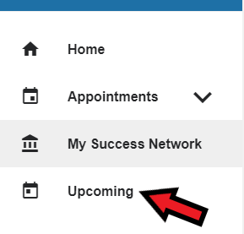
- If your appointment was scheduled, you will see it there.
- When the date of your appointment arrives, make sure to show up at the correct location and on time. If you are 15 minutes late or more, the advisor will have to cancel your appointment and you will have to reschedule.
- If your appointment is through Zoom, your advisor will email you a link to the meeting. Be at your computer at the scheduled start time.Please visit the DePaul Website for instructions on how to use Zoom. Also view the Zoom Website for video tutorials on using Zoom.

